Essay on pollution

What is pollution?

Environmental pollution occurs when pollutants contaminate the natural surroundings. Pollution disturbs the balance of our ecosystems, affect our normal lifestyles and gives rise to human illnesses and global warming. Pollution has reached its peak due to the development and modernization in our lives. With the development of science and technology, there has been a huge growth of human potentials. People have become prisoners of their own creations.

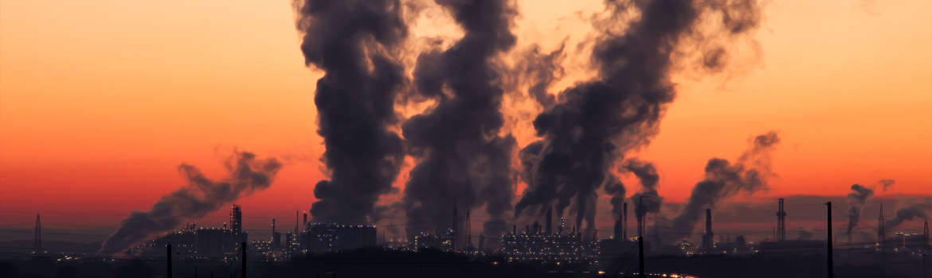

We waste the bounties of our nature without a thought that our actions cause serious problems. We must deepen our knowledge of nature`s laws and broaden our understanding of the laws of the human behaviour in order to deal with pollution problems. So, it is very important to know different types of pollutions, their effects and causes on humanity and the environment we live in.

Types, causes, and effects of pollution

Air pollution is one of the most dangerous forms of pollution. A biological, chemical, and physical alteration of the air occurs when smoke, dust, and any harmful gases enter into the atmosphere and make it difficult for all living beings to survive as the air becomes contaminated. Burning of fossil fuels, agriculture related activities, mining operations, exhaust from industries and factories, and household cleaning products entail air pollution. People release a huge amount of chemical substances in the air every day. The effects of air pollution are alarming. It causes global warming, acid rains, respiratory and heart problems, and eutrophication. A lot of wildlife species are forced to change their habitat in order to survive.

Soil pollution occurs when the presence of pollutants, contaminants, and toxic chemicals in the soil is in high concentration that has negative effect on wildlife, plants, humans, and ground water. Industrial activity, waste disposal, agricultural activities, acid rain, and accidental oil spill are the main causes of soil pollution. This type of contamination influence health of humans, affects the growth of plants, decreases soil fertility, and changes the soil structure.

Water pollution is able to lead our world on a path of destruction. Water is one of the greatest natural resources of the whole humanity. Nothing will be able to live without water. However, we do not appreciate this gift of nature and pollute it without thinking. The key causes of the water pollution are: industrial waste, mining activities, sewage and waste water, accidental oil leakage, marine dumping, chemical pesticides and fertilizers, burning of fossil fuels, animal waste, urban development, global warming, radioactive waste, and leakage from sewer lines. There is less water available for drinking, cooking, irrigating crops, and washing.

Solutions to pollution problems

Environmental pollution has negatively affected the life of both animals and human-beings. The only way to control current environmental issues is to implement conservation methods and create sustainable development strategies. We should find some effective solutions in order to restore our ecological balance.

First of all, we should make sustainable transportation choices. We should take advantage of public transportation, walk or ride bikes whenever possible, consolidate our trips, and consider purchasing an electric car. It is very important to make sustainable food choices. Choose local food whenever possible; buy organically grown vegetables and fruits or grow your own.

People should conserve energy. Turn off electronics and lights when you are not in the room. Consider what small changes can lead to big energy savings. Use energy efficient devices. It is also essential to understand the concept of reduce, Reuse and Recycle. Try to buy used items whenever possible. Choose products with minimal packaging. Buy reusable items. Remember that almost everything that you purchase can be recycled.

Conserve water as much as possible. Dispose of toxic waste properly. Do not use herbicides and pesticides. Use natural, environmentally friendly chemicals for your everyday chores.